PROJECT TITAL:
IOT enabled smart grid

By Faizal khan
Under guidance of my MENTOR
Mr. Aman Singh.

The project is a prototype made under the Summer Training
Cum Internship Program offered by IBM.

ABSTRACT : power consumption has became a concern topic over last few decades, due to increasing in industrial sector in the nation. The main motive of this project is to insure safe and reliable supply of power to every sector by monitoring every home’s and industry’s power consumption. With the help of ARDUINO board and its application it can be easily achieved, thus this project name is IOT based smart grid. The scope of this project Is very vast but due to unavailability of cloud server we shall limit this to our homes only. In My developed prototype of Smart Energy meter, does not have any rotating parts. The energy consumption is calculated using constant voltage and current with help of ACS712. Power is product of voltage and current, its unit watt or KW and energy is product of power (watt) and time (Hour). I have used above mentioned formulas for calculating Total Energy Consumption of consumer with Arduino Programming.
Microcontroller has an interface and we are using 16 X 2 LCD, it is used to show important unit measurements such as voltage, current, frequency, active and reactive power and power factors.
Introduction:
This project gives a reliable monitoring system in home about power consumption, using humidity sensor we can also predict how much power our air conditioning system will consume. Using this project as a daily and conventional way for grid will help to improve power transmission system in India.
With the help of wireless information transmission, the person who has responsibility for grid control can easily know which sector is consuming more power and at what time. This will heavily decrease the chances of power cut in India.
This is same as a conventional energy meter with extra sensors and IOT application.

Some key points-
*it has current meter.
*it has temperature and humidity sensor.
*DIY project
*power consumption can easily be monitored on cell phone.
*can wirelessly send data and instructions

For eliminating bulky system we are using a arduino uno board without voltage and frequency sensor. The board is based on the ATmega328P.
The Arduino Uno is programmed using the Arduino Software (IDE), Arduino Integrated Development Environment common to all Arduino our boards and running both online and offline. For more information on how to get started with the Arduino Software visit the Getting Started page.
Power from the AC mains is drawn and passed through a fuse for avoiding any damage to the circuit board during the accidental short circuit.

Then the AC power line is distributed in two parts:
1. To the load through the current sensor (ACS712)
2. 230V AC/5V DC Power Supply module
The 5V power supply module provides power to the microcontroller (Arduino UNO), the Current sensor (ACS712) and LCD display.

The AC current passing through the load is sensed by the current sensor module (ACS712) and fed to the analog pin (A0) of the Arduino UNO board. Once the analog input is given to Arduino, the measurement of power/energy is done by Arduino sketch.
The calculated power and energy by the Arduino is displayed on a 16*2 LCD.

To make this project more economical we are not using a voltage sensor. The voltage of any single phase supply always remain 230 volts (although we see voltage fluctuations but these are negligible) and the power factor to remains constant (i.e. 0.85).
You can easily get information about power consumption, humidity by sending a signal sms. We can disable our high current supply to by sending a sms.

No wonders, using a voltage sensor as well, will make our energy meter more reliable and precise in measurement but we have to consider economics factor.

Given below is the arrangement of our project:
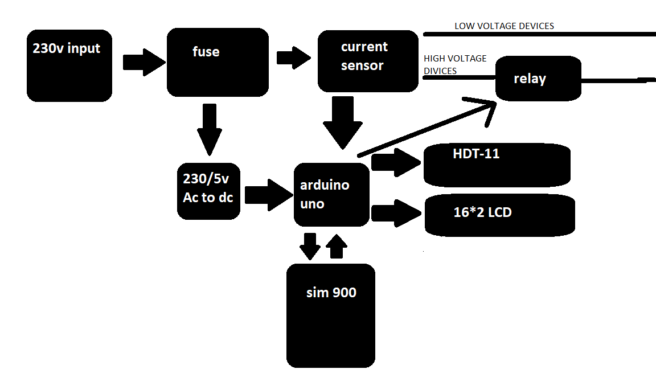

Important sensor used in this project
DHT11 -The DHT11 is a basic, ultra low-cost digital temperature and humidity sensor. It uses a capacitive humidity sensor and a thermistor to measure the surrounding air, and spits out a digital signal on the data pin (no analog input pins needed). Its fairly simple to use, but requires careful timing to grab data.

TECHNICAL DETAILS
- Low cost
- 3 to 5V power and I/O
- 2.5mA max current use during conversion (while requesting data)
- Good for 20-80% humidity readings with 5% accuracy
- Good for 0-50°C temperature readings ±2°C accuracy
- No more than 1 Hz sampling rate (once every second)
- Body size 15.5mm x 12mm x 5.5mm
- 4 pins with 0.1" spacing

Picture below shows the size of a DHT-11 sensor.
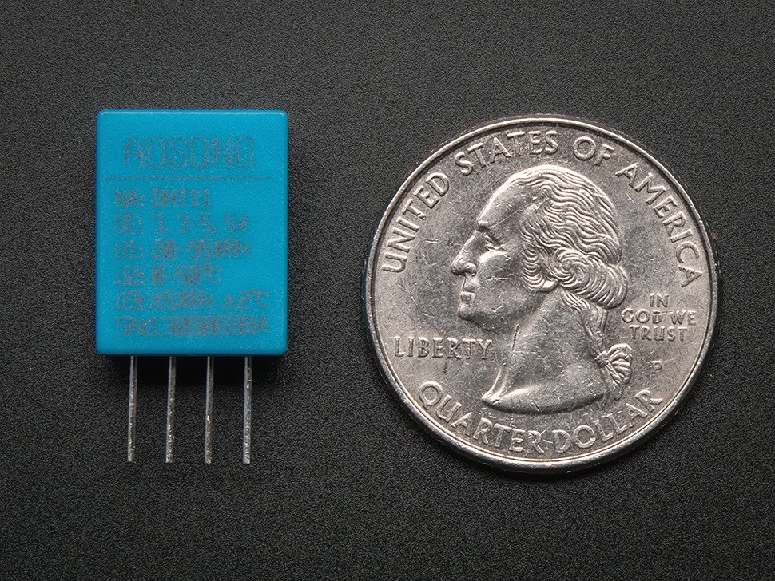
DHT-11 can measure humidity from 20 to 95% and temperature from 0 to 50 degree with 1% error.
ACS 712 - Acs712 is Hall Effect based current sensor. It can measure both direct current and alternating current. It is a linear type sensor. This is very a famous integrated circuit designed by Allegro . It has features of noise cancellation, very high response time. Output error is about 1.5 percent but it can tackle with some intelligent programming and multiplying measured value with standard error of sensor.

TECHNICAL DETAILS
.
- Measures both AC and DC current
- Available as 5A, 20A and 30A module (30A in our case)
- Provides isolation from the load
- Easy to integrate with MCU, since it outputs analog voltage
- Scale Factor

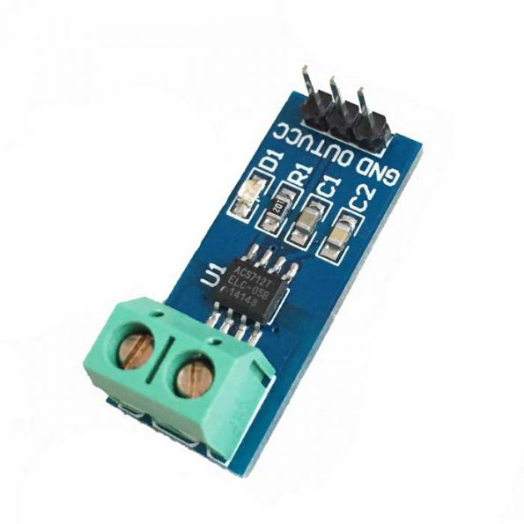
Picture above shows an ACS 712 sensor.

Hardware Overview of SIM900 GSM/GPRS Shield:
The SIM900 GSM/GPRS shield is designed to surround the SIM900 chip with everything necessary to interface with Arduino, plus a few extra goodies to take advantage of the chip’s unique features.
Let’s familiarize ourselves with these features and abilities of the shield. Here’s a quick overview:
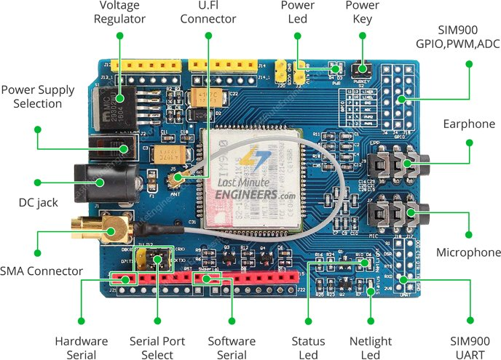
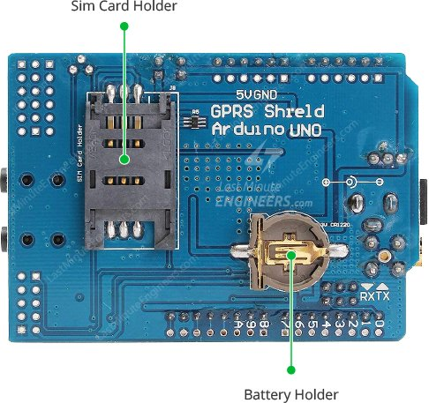
The SIM900 shield packs a surprising amount of features into its little frame. Some of them are listed below:
- Supports Quad-band: GSM850, EGSM900, DCS1800 and PCS1900
- Connect onto any global GSM network with any 2G SIM
- Make and receive voice calls using an external earphone & electret microphone
- Send and receive SMS messages
- Send and receive GPRS data (TCP/IP, HTTP, etc.)
- Scan and receive FM radio broadcasts
- Transmit Power:
  - Class 4 (2W) for GSM850
  - Class 1 (1W) for DCS1800
How this project can help in India power transmission system.
We still don’t have a technology to store electricity in a huge quantity, so every joules of energy which is being produced in power house must be consumed within seconds. The grid department has the responsibility to monitor energy consumption in each sector. It often happens that an industry sector demands higher power due to running of the heavy motors and machine. The energy producing house has a limited capacity of producing energy and if the consumer required more energy than it is being produced, this will drop the conventional voltage (230v) and frequency (50 Hz). If this happens this will damage all the electronics devices and even can damage every electrical device in our home. To counter this problem the grid sector cut down the power supply for residential areas so industry sector can get desire power without causing damage to transmission system. Every sector has priority for power consumption; normally in every case power cut of hospitals happens at last place.

In every home we have 2 supply of current, one is for low load equipments like bulb , TV , fans etc and another one is for high load like motors ,air conditioners ,heaters etc.
The powers consumed by low load equipments are low as compare to high load equipments.
Here our prototype plays an important role.
When ever an industry demands high energy, the grid sector cuts down the power supply of the residential area for protection of the grid.

Since our smart energy meter gives authority to grid controllers to cut down the supply of high load equipments. The grid controllers can cut down the supply of our (residential areas) high load devices. This will heavily decrease the power consumption in our area. The decreased power in our area is a compensation for increased power consumption in industrial area.
By using above method we can have a reliable power transmission in India.

Use of humidity sensor:
Humidity sensor tells us the humidity percentage in the present environment, it also measure the temperature.
The higher the humidity and temperature the higher current will over air conditioner condenser will consume ,thus increasing the power consumption on air conditioner over all.

In our current project, we can get information and send instructions through sms.
Below I have mentioned some commands that I have installed into my project.
These commands can be send through sms and the reply from the project will be directed to the installed mobile no. in the project. The project has its own gsm sim and thus unique mobile no.
Send text(command) to the project no. and you will receive information.
Commands information received
POWER current consumption and power
HUMIDITY humidity percentage and temperature
DECREASE_LOAD cut down high load supply(this can be password based)
Random text will display the text on lcd
Its cons:
Heavily depends on cloud service
Vulnerable from hackers, required high cyber security
Only useful when used into mass quantity
Its pro:
Will improve power transmission
Will decrease energy theft
Easily monitoring

